Introduction

Movie posters are a way to promote actors or actresses’ movies that they acted in. There are several ways to create a poster ranging from promoting the actors or actresses to a scenery from the movie. The creation of my movie poster comes from a Japanese animated show. The background of my movie poster is from one of the scenes of the show where it features two goddesses. The place where these goddesses are in is actually the underworld. It is not a 100 percent acute representation of the world but it is a vision of one of the goddesses who is also the goddesses of the underworld, dreamt of a day where the place is full of flowers. The name of the goddesses are called Ishtar and Ereshkigal. The reason why I chose that scene as my background for my movie poster is because I believe that there could be a movie that talks about these two sisters’ story.

Image and Tools used



This is a kind of a metaphor that represents a soul trapped in a cage in the underworld. The reason why I chose this image is because I want to add something to the background where it is too dull looking. The tools that I use to get one of the pillars is the Crop tool. I decide to use the “Select and Mask” feature instead of using of the three-crop tool. The reason behind this is because there are chances that the crop tools did not crop the places you wanted and have to do some modification to it. Hence, I chose the “Select and Mask” feature where it allows me to brush over the place I want it to be cropped. After that, I used the Eraser tool to clean up the edges of the pillar and unnecessary backgrounds. This allows me to get a cleaner graphic.

The final product looks like the figure above.

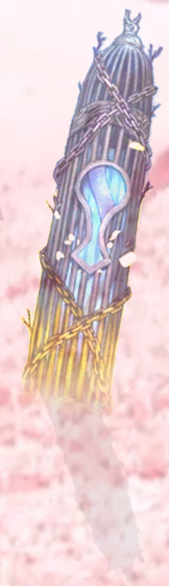

I also used Gradient tool to make it looks like the pillar is in the ground and not like it is floating on the ground. I also used the effect Linear Light to reduce the brightness of the pillar so that it blends well with the background. Drop shadow was used too to give it a more 3D effect.

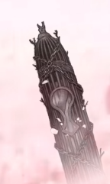

The effect I used on this pillar is called Luminosity where it simulates that the cage is still empty. Some of the effect does not work on any background. The reason I found is that my background is bright.

Type of font and colour used

The font I used is called Stencil for all the description of the poster like the title, tagline, etc. The reason why I used this font type is because the fonts does not look cluttered together and big. The colour that I chose for the fonts is pinkish purple where it blends very well with the background where it is also pinkish due to the flower field.

Theme of the poster

The theme of my movie poster is Hope. The reason why I chose the theme as hope is because they dreamt of having their “playground” full of beautiful flowers and their wish came true. Another reason is that they are fighting against a threat to humanity and risking their life to save the world. That is why I chose my theme as hope because they are our final hope to prevent an annihilation of humanity.

Final Product

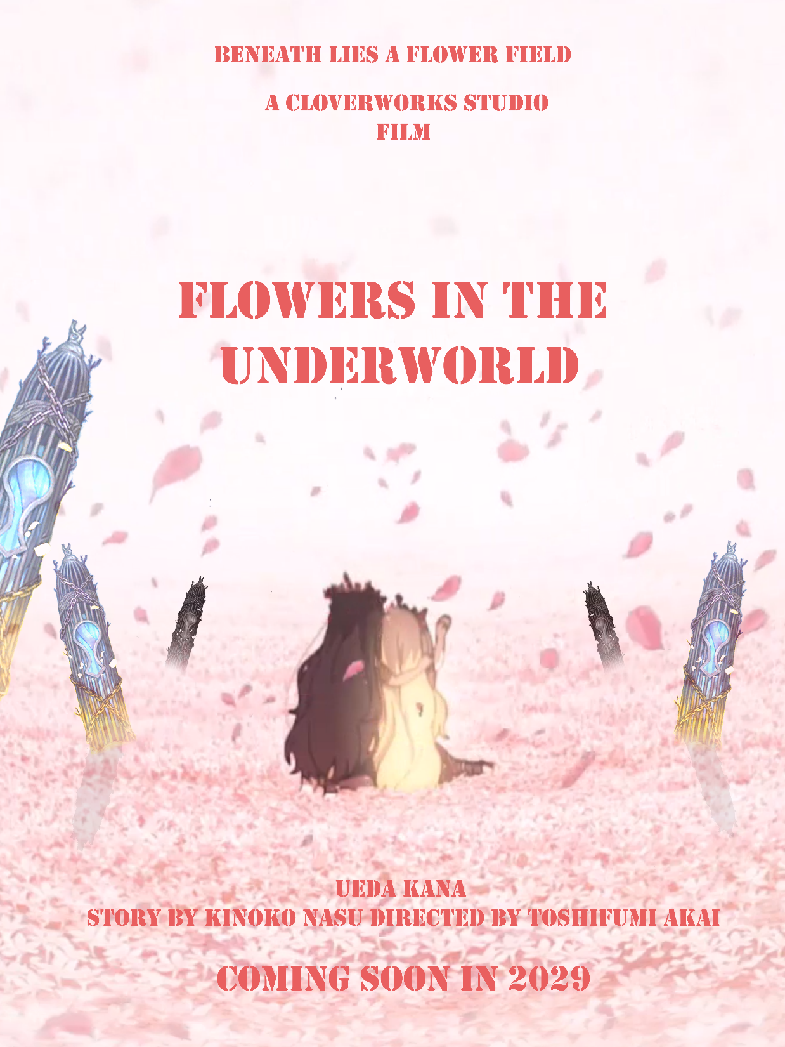

Conclusion

To conclude this report, I could explain more about the show that my idea came from but I do not want to bore my lecturer with my nerdy rant about the show. Overall, this alternative assessment give me an opportunity to create a poster that may not come true. It also sharpen my skills of using Adobe Photoshop where I believe will definitely be used in the work environment.